Lab 6: Blocking Input with Scanner and the Do While Loop
IT 1090C Computer Programming I
IT 6090C Java Programming
Prof. Jason Geanuracos
Fall 2025

Lab 6: Blocking Input with Scanner and the Do While Loop
20 Points

Learning Goals:
- Create Block and Repeat input with Scanner and a Do While Loop to bulletproof input. We no longer have to terminate our programs manually.
- Learn how to generate random integer (int) values with Random
- Learn basic testing approaches
- Learn basic debugging approaches

Mini-lecture:
Last time, we learned how to do input with the Scanner. This time we learn the first of the Java looping structures which allow us to repeat instructions, the do while loop which we saw in PLM.
We will use the do while loop when get input from the user. The loop will repeat until the user enters the data input correctly!

Do While Loop
do
{
// code statements here to prompt the user and use
// Scanner to get the input.
}while(boolean Expression);

Do While Loop Input Example

import java.util.Scanner; // before the class at top of the file
// this code in main:
Scanner in = new Scanner(System.in);
double wage = 0;
String trash = ““; // use for bad input which will read as a String
boolean done = false;
do
{
System.out.print(“Enter your hourly wage: “);
if(in.hasNextDouble()) // OK safe to read in a double
{
wage = in.nextDouble();
in.nextLine(); // clears the newline from the buffer
done = true; // we got a valid number so we can end the loop
}
else
{
// Not a double so use nextLine() instead to read a String
trash = in.nextLine();
System.out.println(“\nYou said your wage was: “ + trash);
System.out.println(“You have to enter a valid amount!”);
}
}while(!done); // initially done is false so !done i.e. NOT FALSE, is true
// when done is true !done i.e. NOT TRUE is false

So, this block of code represents input for one variable. You will use this block multiple times, once for every numeric variable that you need to read in. After you have all the inputs, complete the processing and display the results. Of course, the example is for a double var you have to modify it slightly for an int var. (in.nextInt(). in.hasNextInt()…)

Random Numbers
import java.util.Random; // at the top before the main
Random generator = new Random(); // I usually call it rnd or gen
int val = generator.nextInt(10) + 1; // val is 1 to 10

Lab:
For this lab, complete all the tasks in a single IntelliJ project with a single GitHub repo. Be prepared to provide screenshots to document your program as you progress.
Screenshot shortcut keys
- Windows: Alt + printScrn key puts image of desktop in clipboard. Then paste (ctrl+v) it into the document.
- Mac: Shift + Command + 3 or Shift + Command + 4 to capture a portion of the screen. Then, paste (command + v) it into the document.

You can reach out for help, but each student must complete the tasks and submit the code individually. Make sure you understand the code you submit.
- Create a single IntelliJ project called, "Lab_6_Blocking_Input"
- Add it to GitHub control.
- Add each program as a java class to your project with a main using the name I specified in the task description below.
- Remember, to create the main method within the class, you use the
“psvm” + tab shortcut in IntelliJ’. That will create the code for the entire main() method.
- Be sure to add each program to the repo as you create it and be sure to push and commit your code after you finish each program.

Use the do while loop in each program for every input variable to bulletproof it. Force the user to repeat until they enter correct data. No need to terminate a program now.

Task 1: (5 points)
Program name: CtoFConverter
A program that converts an inputted temperature in C and provides the equivalent temperature in F. (Hint: Google is your friend! Given C, solve for F.) Again, check for a valid input value and only respond with the F value if you got it, otherwise loop until you do.
Testing: Three conditions: Bad Input, then test for the known freezing and boiling points.
Paste a screenshot of INTELLIJ documenting your program test run(s) here.
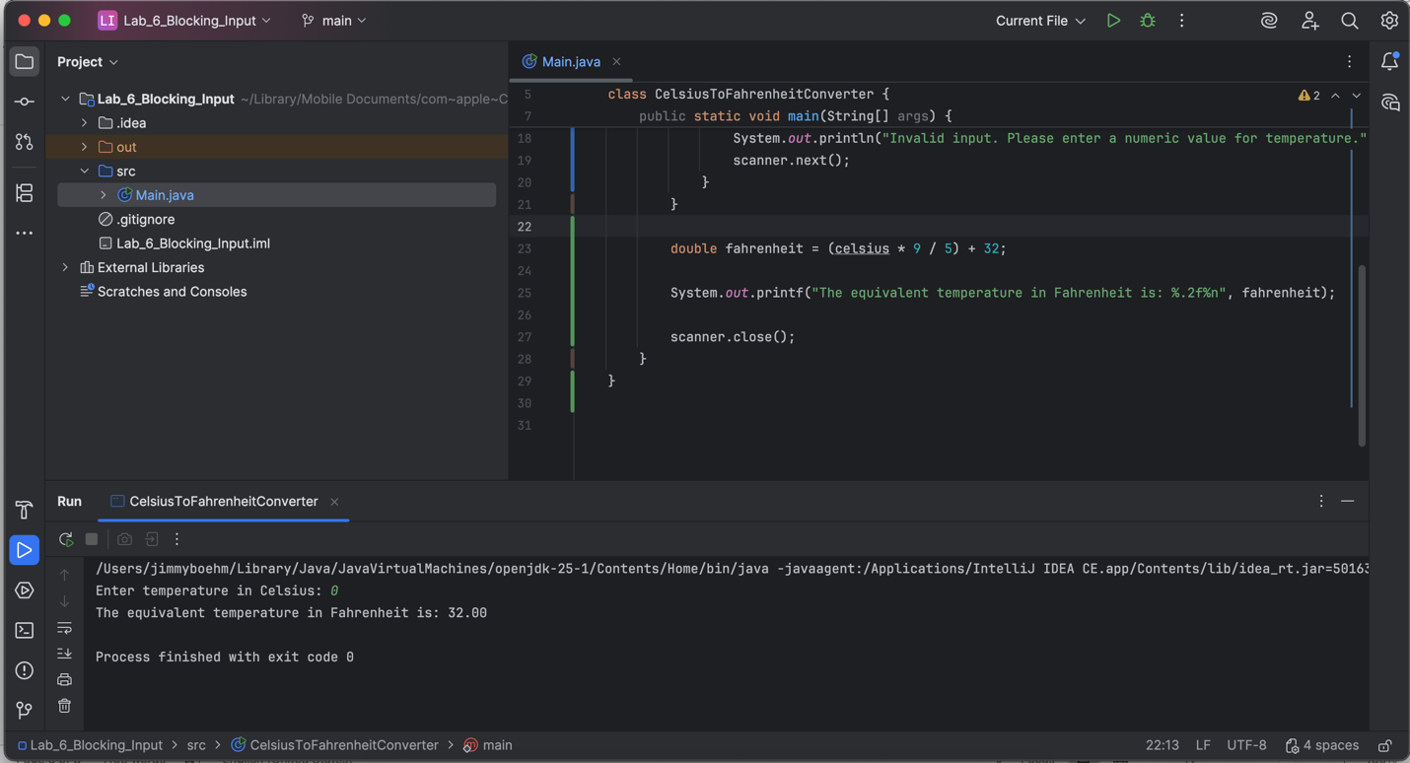
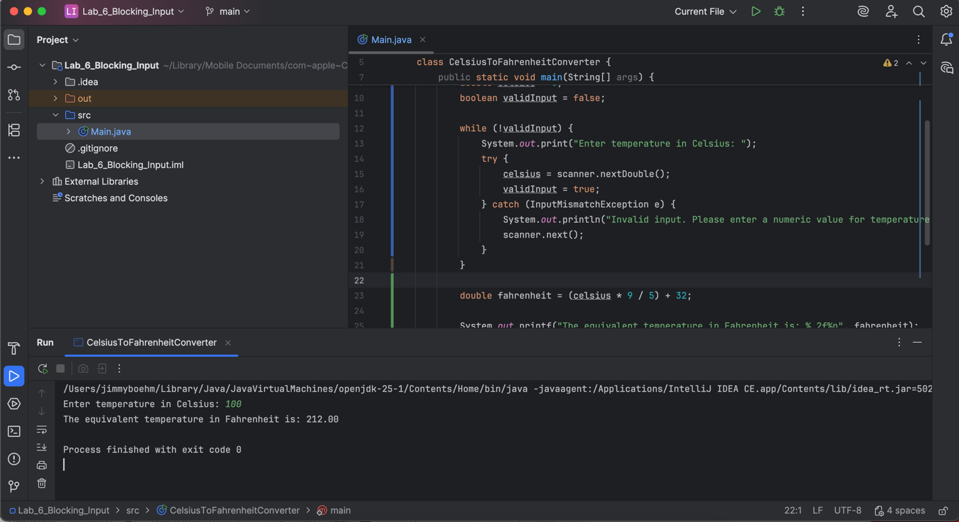

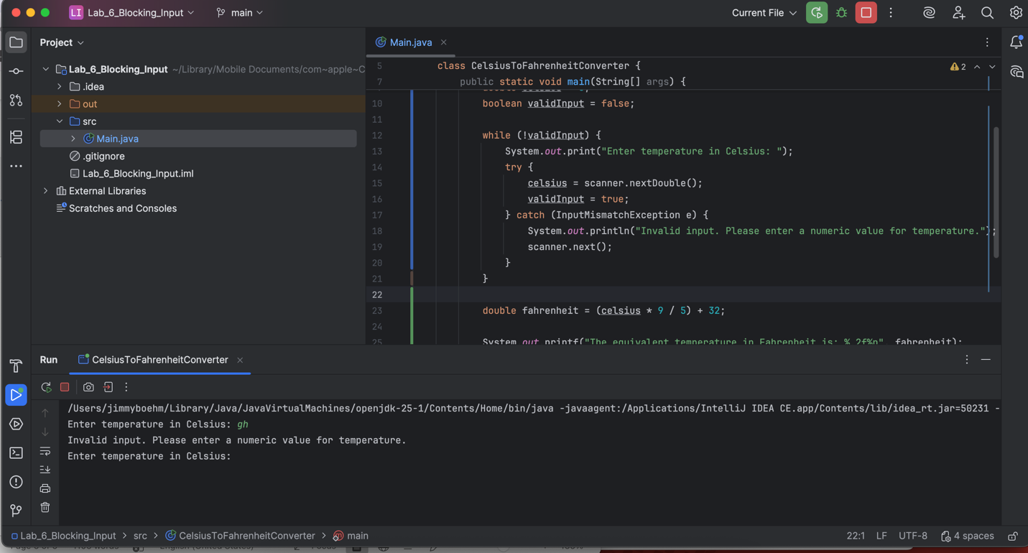

Task 2: (5 points)
Program Name: FuelCosts
Write a program that asks the user to input (should all be type double):
- The number of gallons of gas in the tank
- The fuel efficiency in miles per gallon
- The price of gas per gallon
Again, use a do while loop structure for each variable (3 here!)
Then, print:
- the cost to drive 100 miles and
The cost to drive 100 miles would be .89

- how far the car can go with a full tank of gas.
On a full tank of gas, you can go 2040 Miles.

Testing: Here just use some reasonable values that you can inspect the calculations and determine they are correct.
Paste a screenshot of INTELLIJ documentin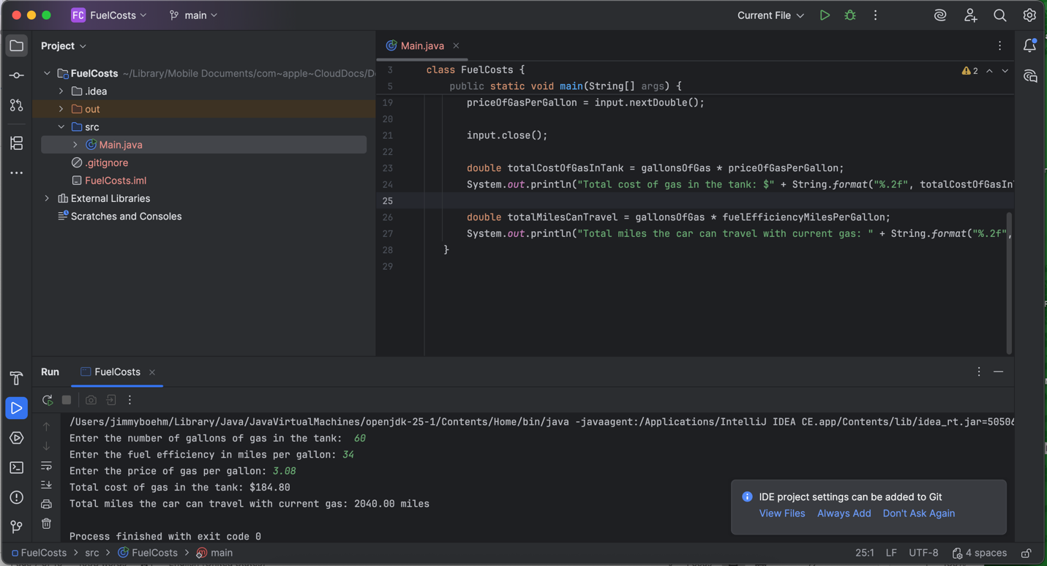
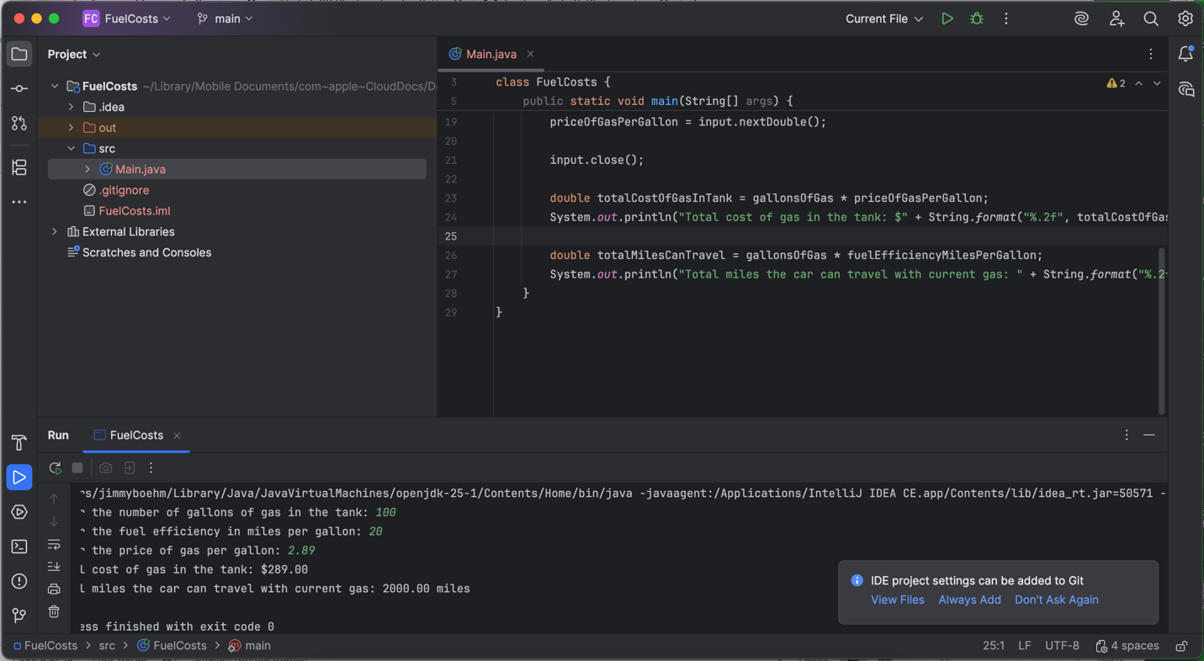

Task 3: (5 points)
Program Name: RectangleInfo
Write a program that asks the user for the lengths of the sides of a rectangle. Again, loop the input until it is valid.
Note: Only two measures here, the Width and the Height should be doubles…
Testing: use some simple values to confirm that the calculations are correct.
Then print
- The area and perimeter of the rectangle
The area of the Rectangle was 180
The perimeter of the Rectangle was 54
- The length of the diagonal (use the Pythagorean theorem)
Note: a 3.0 by 4.0 rectangle will have a diagonal of 5.0
The Diagonal of the rectangle was 17
Paste a screenshot of INTELLIJ documenting your program test run(s) here.
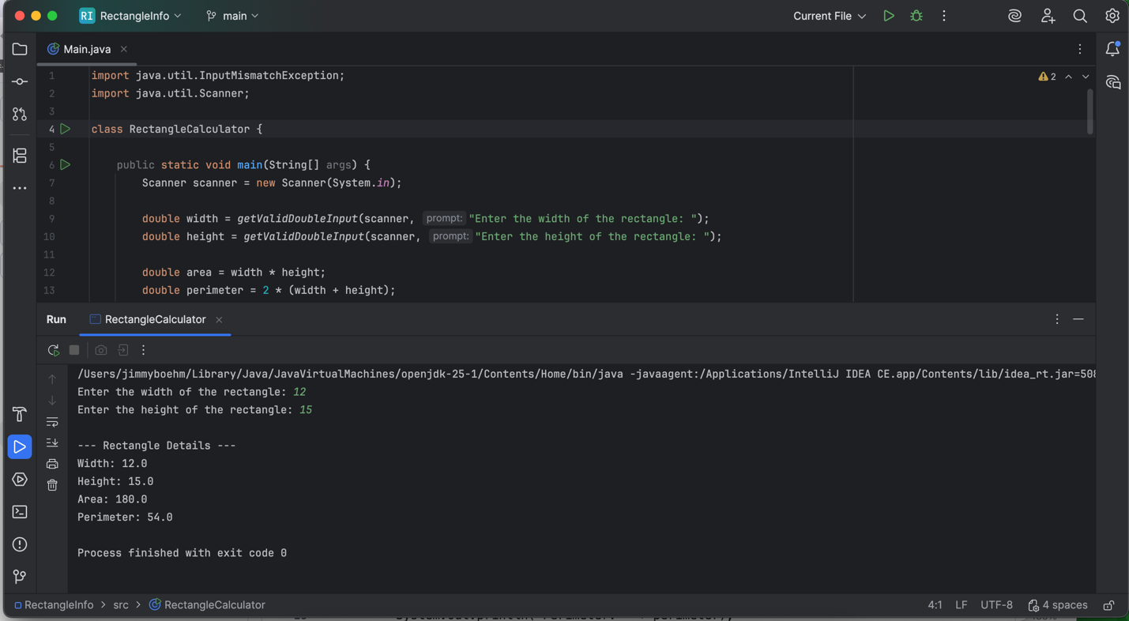
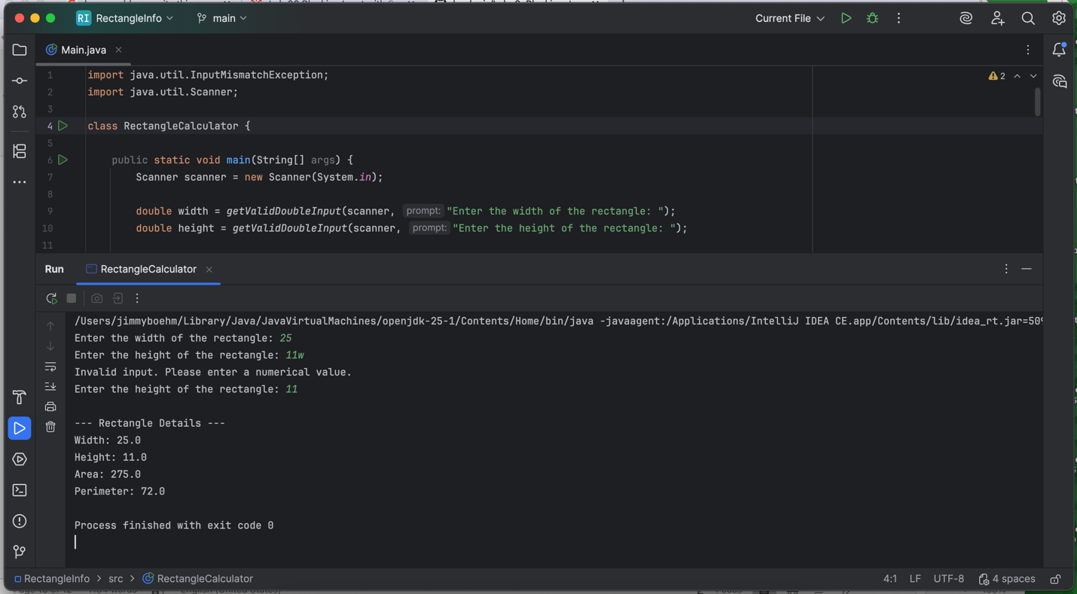

Task 4 (5 points)
Program Name: HighorLow
Write a program that has the computer generate a random int value between 1 to 10 inclusive.
The program then asks the user to guess the number with a single guess.
The program displays the random number and then indicates if the users guess was high low or on the money!
Use the do while loop again to bulletproof the guess which must be an int from 1 to 10 inclusive.
Paste a screenshot of INTELLIJ documenting your program test run(s) here.
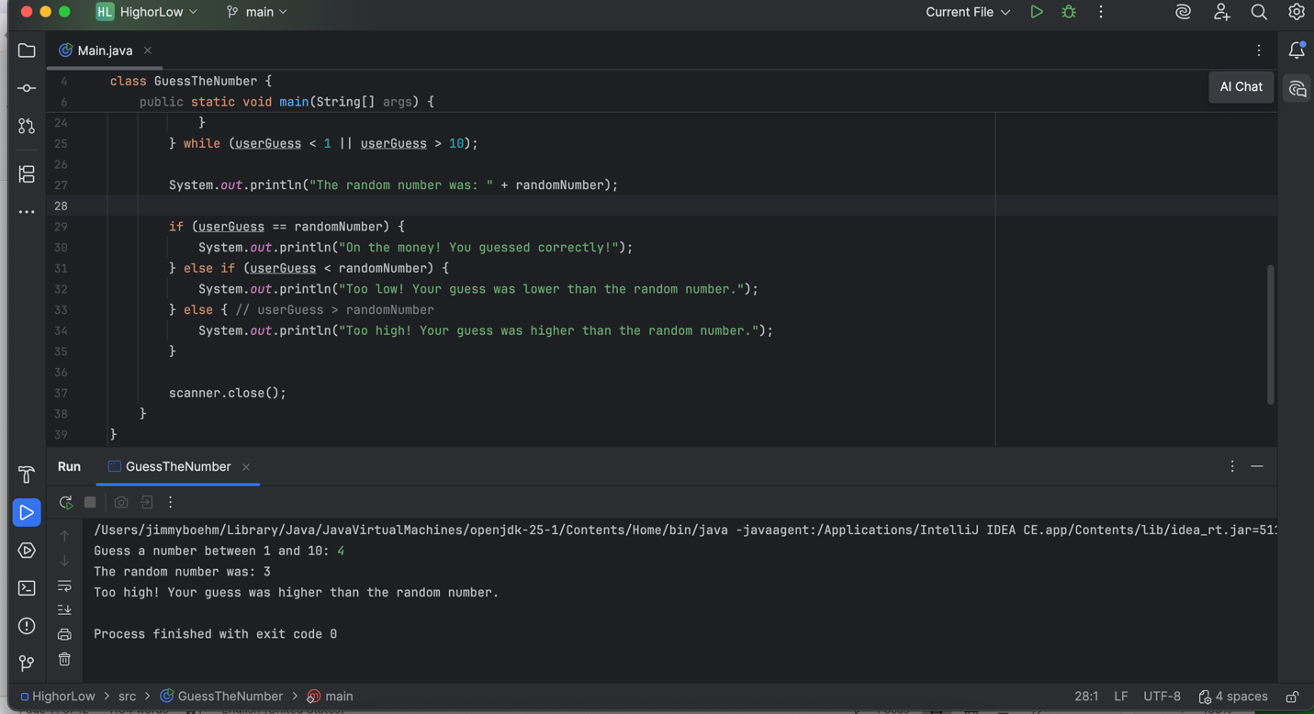

Post-Lab: Double-check Your Work
Now that you have completed the four lab tasks, build constructive professional work habits by carefully rechecking your work, and abiding by the naming format and submission instructions.

Rename this file:
Use the YourLastname_YourFirstname_Lab06.docx format; remember to replace "YourLastname" and "YourFirstname" with your actual names.
The naming format will help us efficiently track and organize your files.

GitHub Link
https://github.com/boehmjs/Lab_6_Blocking_Input

\Submit
Submit to Canvas using the assignments mechanism to upload your document. Don’t submit a link to your document.

